# GPR Quick guide

The guide below provides the basic information to assemble the GPR system, and collect the GPR data, taken from the [PulseEKKO GPR user manual](https://geophysicalequipmentrental.com/files/2020/01/pulseEKKO-Users-Guide-with-Ultra-Receiver-and-DVL-500.pdf) and a reconnaissance trip on 4+5 March, 2023 by Stefan Nielsen, Jenny Jenkins and Jeroen van Hunen.

ASSEMBLY

1. Layout of the GPR equipment in the two storage boxes

1. Place the transmitter and receiver electronic boxes each onto the black mounting blocks in the middle of an antenna, ensuring the brass sockets connect to the brass pins in the antenna. Connect the electronics boxes to the mounting block using the two plastic draw latch connectors.

3) Place one battery on each side of each of the electronics boxes. Make sure the positive (+) terminal faces inward toward the electronics. NOTE: The battery is “keyed” with a notch in one side so it only fits properly in this orientation. Close and latch the battery covers.

1. 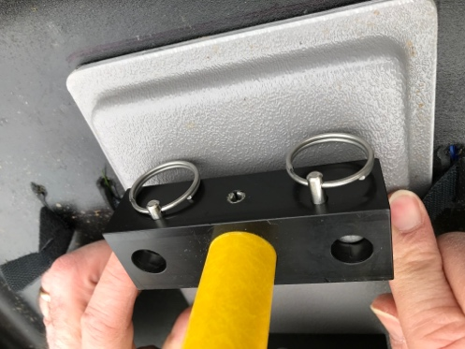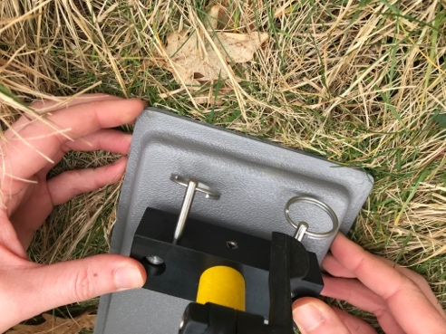To attach the adjustable handle to the antenna, place the handle blocks over the 4 posts on the antenna and insert the pins to secure. Adjust the handle height by loosening the two black levers by hand. Move the handle to the desired height and then retighten the levers. Once the handles are adjusted, lock them by tightening the levers until they click into place.
2. A picture containing grass

   Description automatically generatedAttach antennas to the skid plates with Velcro ties.
3. Connect cables: one connection runs a fibre-optic cable from the back of the DVL to the receiver (red circles) and then another from the receiver to the transmitter (green circles). Make sure the colour on the jackets match the colour of the sockets: black to black and grey to grey.
4. Connect power cable from DVL (blue circle) to DVL battery that can be carried in the designated backpack.

DATA COLLECTION

1. First power up the transmitter and receiver (by pressing the On/Off button on the top of the units). The red Power LED on the top of the unit will flash five times and then stay on to indicate the unit is ready for operation. If the unit doesn’t turn on, check that the transmitter and receiver batteries are fully charged and installed correctly.
2. To start the DVL system, press the red power button. The LED on the front panel will light up red. The smaller led directly above it indicates the battery status: from green (>20%) to orange to red (<10%).
3. The DVL is operated through touch-screen or the buttons below the screen:

11) Choose System Configuration. This will show the screen on the left. Choose a survey name (white bar on top). Small antennas are for 200 MHz recordings (large ones are for 50 MHz). Nr of stacks is a multiple of two: 32768 doesn’t take too long to record (<1 sec) but gives high signal/noise results. The skid plates on the photo above are set up for a 0.5 m antenna separation and ‘broadside’ polarisation. Set the step size to the distance between subsequent measurements. Press ‘back’ to go back to the main menu.

12) Choose ‘scope mode’: Scope Mode enables you to correctly set the First Break. The red line should be as indicated in the figure to the left. If not, adjusting can be done by the ‘Auto Detect First Break’ option, although this does not always work well for the high frequencies used in our setup. With the arrows you can adjust it manually (large arrows to start moving, press again to stop moving; small arrows move the red line by a small increment). Once finished, press ‘back’.

13) Choose ‘run system’ to select the name of the project. Then press ‘back’.

14) Choose ‘line scan’ to start the actual survey. Note 1: the system always seems to complain about low battery. Note 2: don’t press the ‘no save mode’. Note 3: try to keep electronics (such as the GPS system) away from the GPR during measurements.

15) Press ‘start’. Then press the ‘down’ button to make a single measurement (a beep will sound during the measurement: don’t move the device during this beep). Keep pressing the down button to make new measurements.

A display of results will slowly move in from the right of the screen. Once finished, press ‘stop’ and then ‘back’.